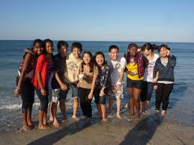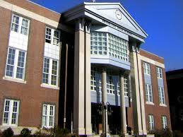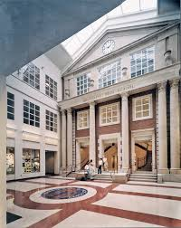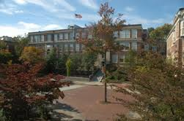

#### Why teach at Brookline High?

#### Culture of high achievement

#### Manageable overall student load

#### Passionate and collaborative faculty

#### Freedom to innovate

#### New teacher program with mentoring

#### High quality professional development

#### Vouchers available to pursue graduate classes

#### Urban/suburban balance

#### On the T

#### Our students need you!

🙞 🙜

Our programs include:

#### METCO

#### African American and Latino Scholars Program

#### AALSP Calculus Project

#### Steps to Success Program (supporting students in public housing)

#### Asian Pacific American Club

#### Race Reels film and discussion program

* Member of Minority Student Achievement Network (MSAN)
* Sojourn to the Past Program

🙞 🙜

Please contact us!

Diversity_Matters

@brookline.k12.ma.us

Keep an eye out for our job openings on SchoolSpring.com.

Brookline High School

115 Greenough Street

Brookline, MA 02445

617-713-5003

(Brookline Hills stop on the Green Line)

bhs.brookline.k12.ma.us

🙞 🙜

🙞 🙜

# Brookline High School

Brookline High has a longstanding commitment to educational equity.

Diversity

Matters

I feel it would be so good to have more staff of color at Brookline High School. It's very clear that the staff is not as diverse as the student body and I'm sort of sad about that. It would help so much -- not just students of color, but everyone.

~ Carlos Fields-Sanders, BHS junior

It would be easier for someone like me to form a relationship with an adult in the building. I don't know how to explain it...and I don't mean any disrespect to all the teachers here right now. I just know that students of color wouldn't be as afraid to go to teachers -- it seems like we'd feel more hopeful about being understood.

~ Elyana Lloyd-Landrum, BHS junior

I don't honestly think it's as powerful an education when your teachers are not diverse. Diversity is so important. So in many ways I feel like I'm missing something...we're all missing something. I would love to have an African-American teacher more than once, or *just* once a teacher of Middle Eastern descent, or an Asian or Latino teacher. Thank you for working on this. How can I help?

~ Kamran Sakhitab, BHS sophomore

Having the opportunity to interact with a teacher who looks like me would have been just that: an opportunity. If I'm going through something that feels specific to my race and life in Boston and there's a teacher in my day who can relate to that part of me, I would just feel so much more comfortable talking to him or her.

~ Brianna Rutty, BHS senior

🙞 🙜

Over the next five years, Brookline High’s population will increase from 1900 to 2300. We are actively seeking a racially diverse pool of applicants for these new positions. We understand how critical it is to make sure our staff reflects the diversity of our student body.

## Brookline High is expanding.

# What’s missing from our school is you.