Brookline Community BHS Educational Visioning
DRAFT Design Patterns 1.0

The following list of priority ‘21st Century Design Patterns’ was developed by mixed teams of workshop participants. Eight teams of six participants worked to create their own priority listing of facility design patterns, after which each team presented to the larger group. Each list was then displayed in a gallery format and participants were given the opportunity to vote for their top six priority design patterns. Patterns are listed below in order of the number of priority votes they received, with each design pattern given six base points for appearing on one of the original team lists, and each subsequent priority vote given one point.
- Flexible Spaces and Furniture (94 votes)

  - Fluid and accessible to all
  - Variable sized classes
  - Movable furniture and walls
  - Flexible technology
  - Spaces that are adaptive (have many uses)
  - Display
  - Light and Flexible furniture for quick “tango”
  - Library, classrooms, cafeteria, school store
  - Breakout spaces in hallways
  - No corridors – flexible use patterns and circulation
  - Less specialization
  - Multi-purpose cafeteria
  - Not isolating groups
  - MLK Room
  - Mid-size flexible commons space
  - Loft or warehouse space
  - Space less formal and institutional
  - Look for new ways to schedule tests and AP exams
  - Good acoustic separation
  - Better systems and habits of sharing space
  - Multi-use auditoriums (small auditoriums)

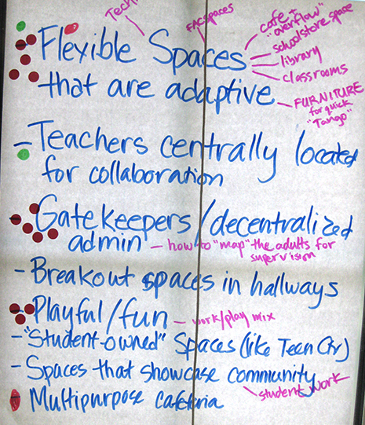
- Commons Areas and Learning Studios (55 votes)
  - Classrooms surrounding a work space
  - Common spaces for work/play mix
  - Student Lounges
  - Spaces that showcase student work and community
  - “Student-owned” spaces like the Teen Center
  - Lecture spaces surrounded by breakout spaces
  - Hallways varied with activity areas

- Teacher Teaming (39 votes)
  - Collaboration of teachers and subjects
  - Faculty interaction (cafeteria)
  - Teachers centrally located
  - Shared department space for all departments
  - Faculty: accidental meetings
  - Faculty conference space

Brookline Community BHS Educational Visioning
DRAFT Design Patterns 1.0 (continued)

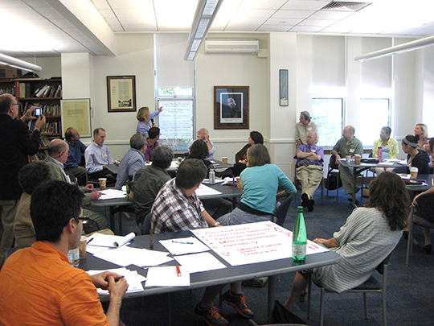
- Greeting and Gatekeeping (33 votes)
  - Safety
  - Welcoming area
  - Entry for community use after school hours
  - Decentralized administration
  - “Mapping” adults for informal supervision
  - Community access

- Visible Community of Learners (24 votes)
  - Spaces that showcase student work
  - Some level of transparency

…………………………………………………………………………………………………………………………………………

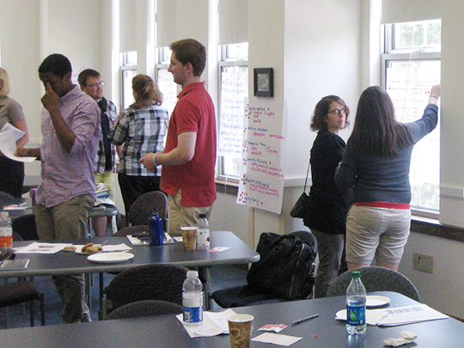
- Maker Spaces (18 votes)
  - FAB Labs with multiple uses
  - Playful and fun – work/play mix

- Integration and Use of Outside Space (16 votes)

- Spa/Gym/Café/Rock Wall (14 votes)

- Adaptive Reuse (12 votes)
  - Rethink use of Language Labs, Cafeteria,
Locker Rooms and Library

- Building as Teacher (9 votes)
  - Green and sustainable

- Ownership of an Area/Space (9 votes)
  - SWS or house system

- Tech Connectivity (7 votes)

- Keep Administration Together (Dean’s Teams) (6 votes)

